A research essay concerning
Electronic Baggage Tags

By: Edris Nazparvar

Technology should be used to aid us in our day-to-day life.

This essay is a collection of Articles concerning Electronic Baggage Tags, an electronic device made for tracking and identifying Baggage.

There are some key questions concerning mentioned subject that this essay will try to provide answers for them.

- What is an Electronic Baggage Tag?
- What are the benefits of using it instead of a traditional paper-based Baggage tag?
- What can be the difficulties of using it?
- what are the technological specifications?

I. Abstract

The aviation sector is one of the industries where Radio Frequency Identification (RFID) and the Internet of Things (IoT) have a lot of promise .

Mislaid baggage, lost baggage, and damage to valuables are the most typical flaws in the aviation industry's baggage handling.
With over two billion people traveling by air each year, the aviation industry is under pressure to enhance baggage monitoring and minimize the use of one-time sticky baggage paper tags.

RFID stands for radio frequency identification and is a kind of automated identification.
To cover all elements of airline baggage monitoring, sortation, and reconciliation, several distinct types of RFID prototype systems are currently being developed.
RFID is not only a viable, unique, and cost-effective choice for everyday object identification, but it is also seen as a critical instrument for providing traceable visibility across the aviation supply chain's many phases.
RFID scanners at check-out facilities allow for step-by-step baggage tracking, preventing baggage loss. The baggage's real-time location is recorded and saved in the cloud via IoT, and the travelers' unique ID may be accessed anywhere and whenever they need it. At check-out counters, the same ID can be used to collect the bag. The technology supplied saves time, assures baggage security, and is cost-effective, resulting in customer happiness.

II. Introduction

In 2009, global airlines lost 25 million pieces of passenger baggage ^{[1]}. On foreign flights in 2011, 26 million pieces of checked baggage were missing ^{[2]}. 25.8 million pieces of baggage were mishandled in 2012, with 85 percent being delayed and 15% being damaged or lost ^{[3]} .
Some baggage is located following track and trace within a few hours, while others are declared permanently lost. Airports and airlines expend enormous energy to seek down and return lost baggage to passengers, at tremendous expense; Swedberg ^{[6]} estimated an annual cost of US$750 million to track down and restore lost baggage to its owner through airline, airport, and courier.

The IATA RP1740c protocol is the one that is used to recognize RFID baggage tags.

The RFID tags are used to enhance the ability for baggage tracking, dispatching and conveyance to improve the management efficiency and the users’ satisfaction.
The fundamental RFID system is composed of three components:

- Transponder/Tag
- Reader
- Backend Application.

RFID technology has been investigated and deployed in a number of airports across the world, including Heathrow Airport in London, Kansai International Airport in Japan, and Hong Kong International Airport in Hong Kong.

III. Background

III.A: Standard

There are two important standards that will play significant roles in the supply chain:

- The ISO 18000 serial standard developed by the International Standards Organization (ISO)
- The EPC standard advanced by EPCglobal

The EPC standard addresses air interfaces, the format for product identification data contained in RFID tags, middleware ^{[74]} , and databases that hold tag data. The ISO 18000-6C standard was met by the EPC Class -1 Generation 2 UHF Specification provided by EPCglobal. It specifies the specifications for a radio-frequency identification system operating in the 860MHz to 960MHz frequency band with passive-back scatter and Interrogator talk first. This frequency range avoids regional variances in UHF radio spectrum allotment for RFID, such as in North America (902 to 928MHz), Europe (865.6 to 867.6MHz), and Japan (from 953 to 954MHz) ^{[62]} .
An interrogator (also known as a reader) is in charge of reading data from a tag by sending it a continuous-wave RF signal. The tag replies by modifying its antenna's reflection coefficient, backscattering an information signal to the interrogator. The RF signal provides both information and working energy to the tag, which is passive ^{[48]} . Because UHF works well in dry, non-metallic settings, it is recommended that the aircraft baggage tag operate in the UHF frequency range.
The UHF RFID tag could be reprogrammed and reused.
By establishing self-service kiosks, operating expenses might be minimized.
With the use of RFID in baggage tracking, smartphone apps might be used to show and interact with human and tracking data. Users may track and trace the whereabouts of their baggage using their mobile devices at any time and from any location. The smartphone software might also show real-time flight information and help with the check-in procedure. It might also serve as a communication hub between the traveler and the airline prior to departure. Airline shopping combined with commercial transactions conducted through mobile applications might result in added value and client retention.

III.B: IATA

In terms of baggage handling regulations, the IATA, in collaboration with airline companies, airports, and RFID vendors, addresses the open protocol known as RP1740c ^{[46][54]} .
It specifies that the air interface used is ISO 18000-6C, and that the application protocol is ISO/IEC 15961 & 15962, which describe data compression for storage and the instructions that may be used to interact with the tag, respectively.
Table 1 also includes other IATA procedures that were used in our research (based on ^{[60]} ).

Object | IATA | Scope & Description
Baggage Tag | IATA Resolution 740 (IATA License Plate) | The License Plate Number (LPN) is a unique 10 digit number (1 digit: prefix to indicate general classification of tag; 3 digit: airline ticket number; 6 digit: serial number) generated by accepting check- in system, which enables the identification of a single bag. The LPN is visually printed on each baggage strip.
RFID Standard for Baggage Tags | IATA Recommended Practice RP1740c | supports the use of RFID luggage tags that operate at ultra-high frequencies along with readers (interrogators) that adhere to the ISO 18000-6C protocol.
Baggage Services Messages | IATA Recommended Practice RP1745 | Baggage Messages are well-defined text message that allow structure data exchange between all involved systems, for example, DCS (Departure control system), BRS (Baggage Reconciliation System). Message types BSM (Baggage Service Message) and etc.

III.C: Airports & Airlines

Many airlines and airports, such as Hong Kong International Airport, Delta Airlines, McCarran International Airport, British Airways/Heathrow Airport, Singapore Airlines, and Narita International Airport, have been working on the conversion from traditional barcodebased baggage handling
to RFID.
There are two types of
RFID based BHS adoption mechanisms. In the initial application form, lowcost tags
(about $0.25 per tag) are used to index a single piece of baggage, similar to how one plate for one automobile is utilized.

Only when the backdrop has been established can baggage information such as the owner,
origin, and destination be enquired about.

The advantage of this manner is that the one-time tag is inexpensive, and the reader software is simple to implement, but the back infrastructure is sophisticated, and off-line baggage information disposal is not supported.
In the second case, more expensive tags with more memory are employed to keep precise information about the baggage, and the status of the baggage may be tracked at every stage once it reaches the airport. The front-end reader is more difficult to install, but the demand on the back-end system is reduced, and off-line inquiry by portable reader or otherwise is supported. In this mode, the tag's cost is higher, allowing it to be recycled.

IV. Application

IV.A: Design

Figure 0 depicts the experimental setup. The UHF tag is sealed inside the barcode-printed baggage strip, and dual mode baggage handling operations are available. With minimal work and cost, RFID can complement the industry's present barcode-based automated handling solutions.
One RFID Tracking Node consists of a TCP/IP-enabled reader and two or three fixed antennas that emit RF signals in several directions

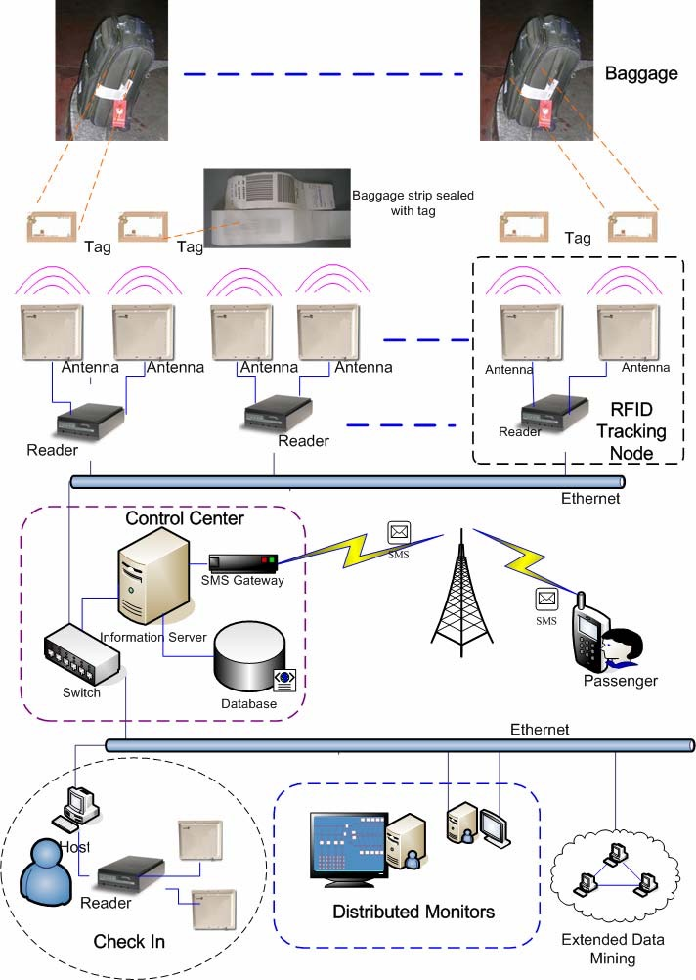
Figure 0: Topology of the RFID-Based Traceable Air Baggage Handling System
IV.A: Design

Each node is placed at a crucial location in the handling area to scan and update information on the baggage moving through.
The physical foundation tier of the system is made up of all of the baggage strips with tags and the tracking nodes.
When a departing passenger checks in, the license plate number is not only written in human-readable barcode format on the strip, but it is also translated and saved in one memory block of the RFID tag sealed in the strip.
Along with the LPN, the tag stores the Carrier ID, Destination, Date, Time, Passenger Name, Passenger Mobile, CRC, and other information.
The Control Center, which includes modules like the reader manager and event manager, is in charge of harmonizing huge groups of readers, even if they are dissimilar.
The raw data or events connected to the tags must be filtered, aggregated, and cleaned to eliminate redundancies since the original data requested from RFID monitoring nodes is too vast.
Duplicate entries resulting from several readings of the same bag at the same place, for example, are combined. After filtering and smoothing, the tag reading data in the database can be compressed and processed in a variety of ways.
When using these additional procedures, there are various considerations to consider. For example, when the system scale is inside one terminal of the airport, these operations can be avoided. Web Services are used by the Information Server to provide service interfaces and APIs to human interaction applications.
These given services place a premium on the question of baggage placement.
In Distributed Monitors, the query results may be shown on a GIS map.
Furthermore, when the correct scenario is identified by RFID Tracking Node, various services may be provided to users' wireless mobile terminals, such as alerting the passenger that his baggage has been successfully loaded on the airplane.
On the GUI of distributed monitors, we track all local and transfer baggage from customer check-in through placement into containers for aircraft using meaning information abstracted from the primitive data.

Some researchers created additional devices, such as a bracelet ^{[23]} and a smartwatch ^{[41]} , to help with baggage monitoring and receiving information. Instead of one-time RFID baggage tags, extra accessories, and web-based tracking, the suggested RFID cyber-physical system's architecture includes an integrated reusable baggage tag that is linked to the baggage. With the help of mobile application devices, the location of the baggage may be tracked at any time.

IV.B: Framework and Components

The RFID tag is UHF (862–900 MHz) and has a unique identification number. This corresponds to the 850–950 MHz frequency spectrum set by the International Air Transport Association (IATA) for RFID baggage tags. The RFID antenna is utilized to identify the tag as well as receive the tag's broadcast signal. The data is sent over the network by the reader to a DMS.
The use of a document management system (DMS) to monitor, manage, and store documents reduces the amount of paper needed.
The data is subsequently processed by the DMS and sent to the mobile app. The data obtained from the airline, airport terminal, and mobile app application is also integrated into the DMS. The mobile application is loaded on a smartphone mobile device and allows tourists to follow their baggage using the app's mobile tracking features.

IV.C: Integrated Structure

The developed integrated system consists of a web server and a database server. The web server covers the operation of the webpage and the communication between the external workstations and internal servers. The communication includes queries and commands transmitted through the web server. The database server connects the RFID reader, stores the data, and manages the information of the RFID tag.
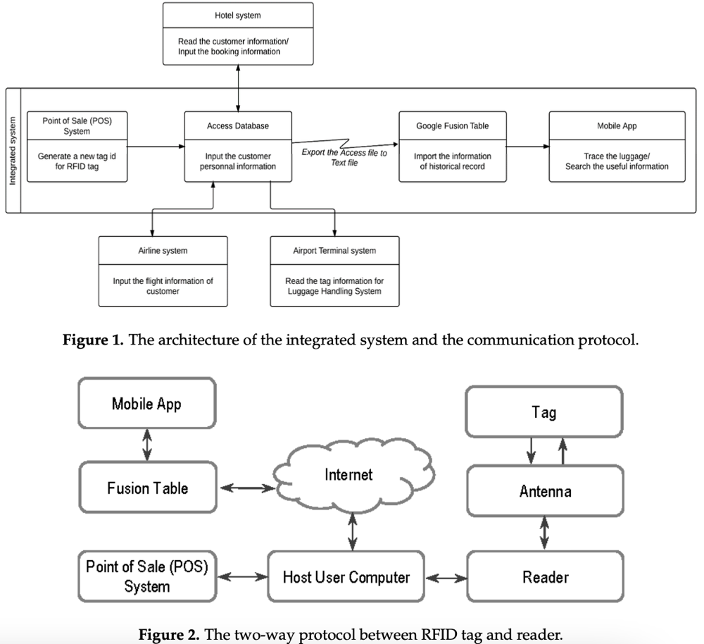
IV.C: Integrated Structure

Figure 1 depicts the architecture of the integrated system as well as the communication protocol. The reader transmits signals to the tag and receives the answers using two-way radio transmitter-receivers. Figure 2 depicts the two-way procedure. The Point-of-Sale (POS) system generates a new tag identifier for the RFID tag, which is subsequently transmitted to the Access database. Additional consumer personal information might be simply entered into the POS or database.
The Access file is instantly exported to a Google Fusion Table, which keeps track of the most recent and previous baggage tracking information. The information is updated on the Mobile App, allowing users to track their bags and look for relevant baggage and flight schedule information.

IV.D: Implementation

The program is installed at BCIA Terminal 2, one of China's largest passenger terminals, which houses virtually all of the airlines' domestic and international flights departing from Beijing. One RFID EPC C1 G2 UHF tag from 'UPM Raflatac' ^{[70]} is sealed in each baggage strip.
(as shown in Figure 3-a).
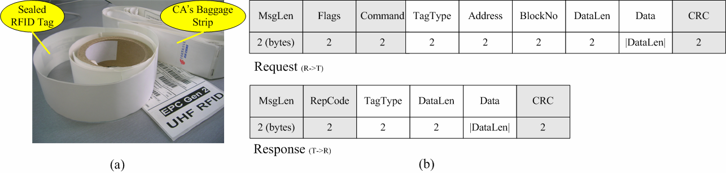
Figure 3: (a) Tags for Implementation (b) Defined Protocol of Reading/Writing Command between Read and Tag

IV.D: Implementation

In this scenario, one tag corresponds to a piece of baggage and a passenger with his E-TKT. These Gen 2 tags are ISO 18000-6C compliant and are more accessible. We set readers with three antennae called 'Intermec IF5' ^{[58]} (as shown in Figure 4) in the tracking zones of the T2 BHS area, such as behind the security check area, the end of the check-in island, baggage conveyor belt, manual recode station, and sorting exit for each aircraft (as illustrated in Figure 0).
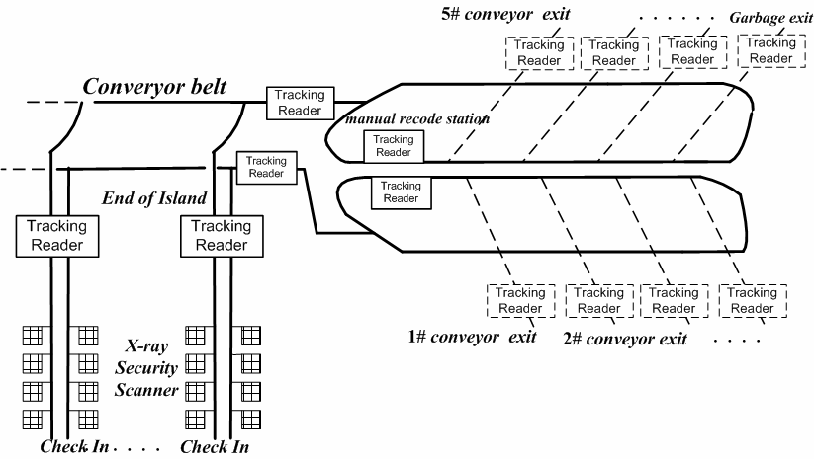
Figure 4 Layout of the System Implementation inside the BCIA Terminal 2

TCP/IP Ethernet connects all of the readers to the control center. The tag may be read at a distance by any of the antennas using the command packet (Figure 3-b) transmitted by the reader, and many bags can be read at the same time. The protocol between the reader and the tag is depicted by the command request/response format. Where the 'Flags' designate the tag query mode as select, inventory, or loop; the 'TagType' describes the object tag type as EPC C1 Gen2, ISO 18000-C, or auto-detect; the 'Address' and 'BlockNo' specify the memory bank for reading or writing the tag; and the 'CRC' is the calculated CCITT-16 cyclic redundancy check.
We put a single LED screen above each conveyor exit that is pre-programmed for one specific planned flight. The quantity of sorted and sorting baggage for this flight is displayed on the screen. The number of pieces of baggage that were properly sorted and those that were sent to the error sorting conveyor exit are displayed on the distributed monitor. The GPRS Web gateway offered by 'China Mobile' is installed in the control center, as SMS has grown in popularity as a means for mobile data transmission. In ISendSMS.jsp, we call the sendSMS function (String content, String mobilePhones, String priority, String messageFlag, String moduleName, String exNumber) to send a confirmation message indicating if the baggage has been successfully sorted before the passenger boards the plane. The use of SMS will provide travelers with real-time feedback and increase passenger happiness.

IV.D: Experiment Results

The processing results are evaluated in the baggage handling system's hostile physical environment. We evaluate the read rate of the departing baggage on the assumption that RFID is introduced for one specific scheduled aircraft of AIR CHINA (CA) within two months (from May 16, 2006 to June 19, 2006). Here, the read rate is defined as follows:

$$Read Rate=\frac{Correct Handled Number}{Total Number} X100$$
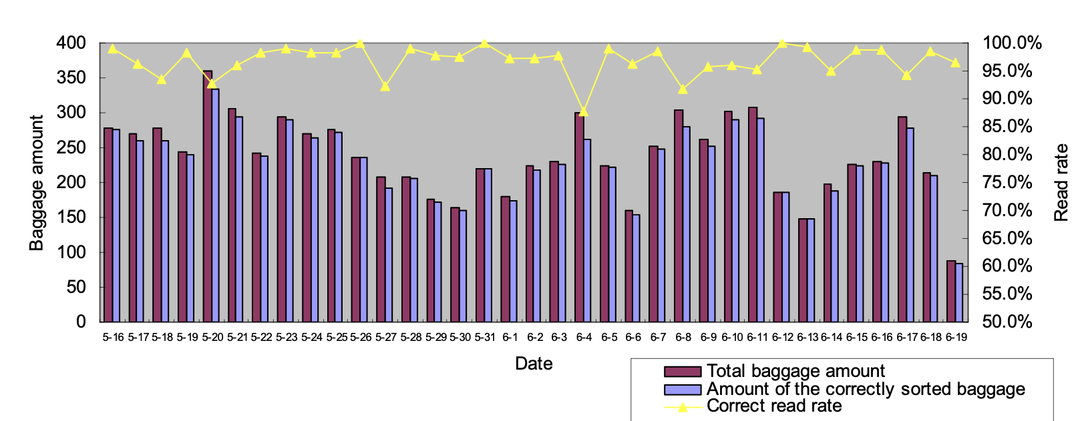
Figure 5: Read Rate of the Experimental Results for RFID-Based BHS

On the distributed monitors' GUI, the number of appropriately handled pieces of bags that transit the accurate conveyor exit point automatically increases for the trial planned flight. All misread baggage is moved to the designated 'trash' conveyor exit, where it will be scanned with a hand-held reader and manually sorted. Although the baggage amount in this trial does not cover all BCIA flights, the experimental data spanning nearly two months for one trip can illustrate the RFID solution's baggage delivery performance.
According to the results shown in Figure 5, the average of varying baggage read rates is 96.86 percent, which is a significant improvement over a barcode-only system (according to the IATA, barcode baggage tag read rates average 85 percent, though other industry experts put that average at 75 percent). ( ^{[61] and [63]} ). Furthermore, the increased visibility of baggage precise tracking on dispersed monitors increases the industrial field worker's process management ability and helps to boost baggage security.

V. IoT—Database Management System,
Fusion Table and Mobile Tracking

Because of its interoperability and connectivity with other databases, user-friendly programming interfaces, and widespread use in the industry, the DMS is built using Microsoft Access.
With flight information, baggage tag personal information, and other data maintained in an organized manner, Access allows for efficient data storage and retrieval. For data retrieval and record transactions, Access provides queries and form methods. Access also allows you to export data to Google Fusion Table for further data processing in mobile apps. Tag information, customers table, flight information table, stocks table, retail store table, baggage history, baggage location, hotel table, and airline table are all established in the DMS. The majority of the tables are linked together using main and foreign keys.
The relationship begins when a retail store sells baggage with an RFID tag, which is reflected in the POS, and ends when a traveler brings the baggage to the airport during a flying journey.
As an item of baggage, the connection between the consumer and the baggage is one-to-many. Figure 6 depicts the interaction between tag information, retail store for tag, customer information, baggage location, hotel, and airline. Aside from the nine tables, the data structure contains five forms for customer, hotel, and tag information.
The baggage tag identification number, time, and matching location are shown in the baggage tag history table of access to allow tourists to follow their baggage using mobile devices.
For example, on August 18, 2022, at 20:30, a tag with the identifying number '000000000176' will be shown on the traveler's mobile device.

V. IoT—Database Management System,
Fusion Table and Mobile Tracking
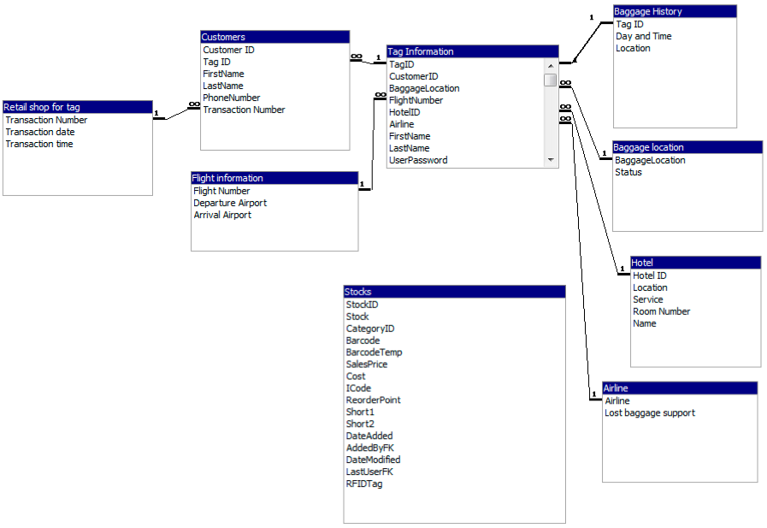 Figure 6. The relationship diagram of the database management system.

Ten milestones are identified in the baggage process flow with RFID antenna set up as check points to identify the important milestones for baggage tracking and tracing. After being purchased in a retail store, the tag is assigned the default status of ‘ready to use,' which is updated in the POS system. When the traveler enters the airport premises, the baggage status is changed to 'airport area,' and then to 'check-in counter,' after the baggage has been checked in. Other baggage status, such as 'conveyor belt, “in-transit to airport, ‘loading off, ‘loading onboard,' and 'onboard,' depicts the subsequent status at the outbound airport.
The status 'onboard' will be shown to travelers in the mobile app to enable for improved baggage management between the traveler's origin and destination. The baggage will be loaded off and moved to the conveyor belt in various future states, such as when arriving at the destination. For tourists to verify the status of their baggage, these two procedures are provided in the smartphone app. The important milestones of the baggage process flow are depicted in Figure 7.
The procedure depicted in the picture with an RFID antenna symbol represents the region that will be tracked and presented in the mobile app.
V. IoT—Database Management System,
Fusion Table and Mobile Tracking
The Android Software Development Kit (SDK) and MIT App Inventor 2 (AI2) are used to create the mobile app ^{[42]}. SDK is utilized because it facilitates the building of applications for software packages, hardware platforms, and computer systems, and it supports the Java and C++ coding platforms. AI2 is a cloud-based application that runs in the Google Chrome browser and includes the Adobe Flash Player. To create the mobile app, AI2 uses Block Editors. The App Inventor block editor was used to create the baggage tracking, history log display, and login elements of the mobile app. Figure 8 depicts the user interfaces built for the mobile app's login and primary menu pages.
Users may log in using their e-mail address, barcode scanner, or Near Field Communication (NFC) device (NFC). The main page connects to the Tracking, History, Information, and Setting modules of the user interface. The mobile app is meant to show the most recent state as well as the history of the prior five statuses.
Their user interfaces are shown in Figure 9.
The connection between the Access database and the mobile app involves the usage of Google's Fusion table. It stores the data using IoT technologies before showing it on the mobile app. Examples of the Fusion tables are provided in Figures 10 and 11. From the generation of the tag in the POS through the updating of the tag and customer information to the following statuses observed in the reader, the built IoTs are put to the test.
When the reading distance is larger than three meters and the tag moves around the perimeter of the antenna, the performance of the reading range has been evaluated. When compared to similar RFID performance tests ^{[12]}, the reading performance is adequate. Figures 2 and 7 from the previous sections may be used to determine the flow and condition. A baggage safe protector module in the mobile application has been built with login identification by password validation, QR code or NFC scan, taking security and privacy into account. For security concerns, the information saved in the tag is restricted to the name and cellphone number during the early development stage.

V. IoT—Database Management System,
Fusion Table and Mobile Tracking

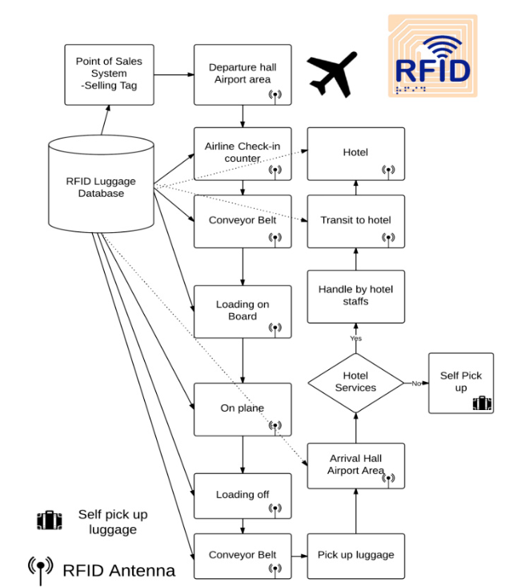
Figure 7. Major milestones in the baggage flow.

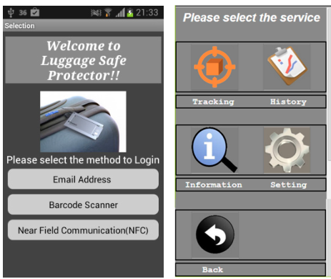
Figure 8. The user interfaces on login page and main page of mobile tracking app.
V. IoT—Database Management System,
Fusion Table and Mobile Tracking

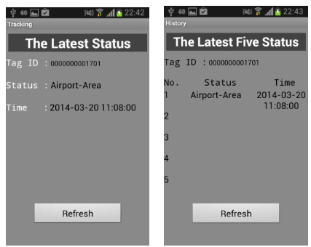
Figure 9: The user interfaces on the tracking page and history page.

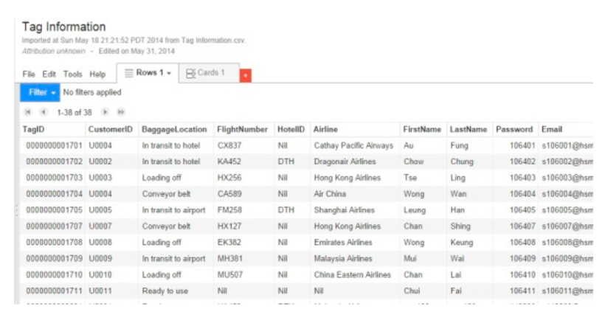
Figure 10. Fusion table in the web as linkage and database for mobile application.
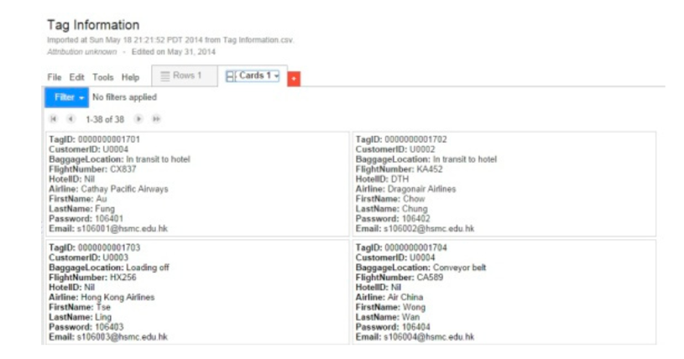
Figure 11. Fusion table for the tag ID and the associated tag information.
V. IoT—Database Management System,
Fusion Table and Mobile Tracking

In recent years, airlines and airports have conducted trials and deployments of RFID on baggage handling. In 2005, Hong Kong, Milan Malpensa, and Las Vegas McCarran airports were the first to implement RFID in airports ^{[43]}. The read rate of the new bar codes is over 97 percent, compared to roughly 80 percent for traditional bar codes. Through more precise tag reading and greater visibility across the whole baggage operation, RFID is expected to cut mishandling by 20%. Other airlines and airports have also conducted trials, such as British Airways at Heathrow, Japan Airlines at Kansai International Airport and Hong Kong International Airport, Kuala Lumpur International Airport, and Korean airports, among others. RFID's advantages in baggage handling include not just minimizing mistreatment and improving visibility, but also improved monitoring and lowering the usage of paper sticky baggage tags. Through partnership between the airport, airline, and baggage maker, technology and research for reusable baggage tags should advance for baggage monitoring anytime, anyplace. The usage of a reusable baggage tag in conjunction with an RFID tag implanted in the baggage might help to decrease the annual waste of billions of adhesive baggage tags.
This has a good influence on the environment since it eliminates waste that is harmful to the ecosystem. The use of mobile tracking for baggage management connects the passenger to the baggage position and flight information. With baggage monitoring, hotels participating in the project can improve their check-in process and deliver better customer service. Further development will require integration throughout the systems, including the POS, DMS, mobile applications, airport check-in counters, destination airports, and hotels, with the created IT with DMS, fusion table, and mobile tracking functions.

VI. Challenges

Various hurdles await the complete adoption of baggage monitoring from retail to airport and then to hotel systems.
Various counterparties in the chain, including the baggage maker, retail store, airport, airline, hotel, and customs, must communicate and collaborate. Platforms for data exchange, system integration, and information flow among diverse stakeholders, as mentioned in previous sections, must be built.
Acceptance from all parties involved is another stumbling block to a successful launch. In everyday operations, workers who are accustomed to the existing practice rely on the Kanban method. The transition from paper sticky baggage tags to digital information necessitates frontline worker training and instruction.
When a reader detects the position of the baggage, it is able to track the baggage's location but not its direction. The system might be blamed for a lack of vector data. Detecting whether a person is coming or exiting an airport when many signals are intercepted in the same location, for example, might be contentious. The use of IoT baggage tracking may not be enough to completely eradicate misplaced baggage.
Theft could still occur at the airport baggage pickup area.
Security would be critical to safeguard the growing amount of user data contained in the tag, as well as the interfaces between the tag, readers, and IoT devices. The RFID tag is permanently lodged in the baggage to prevent it from being removed or the baggage ID from being changed. By implementing new security measures, security might be improved further.
a unique ID number encoded in the tag which links to a protected and encrypted database.
Reader-tag authorization and shifting data into backend could be implemented to enhance the security system.

VI.A: Infrastructure

Building a UHF RFID infrastructure across the whole aviation industry chain is seen as critical to achieving greater real-world efficiency. According to an IATA estimate ^{[57]} , the top 80 airports must be equipped with RFID in order to reap worldwide advantages, since RFID can cover up to 80% of all baggage mishandling.
Because baggage moves throughout the world, infrastructure should be put in place to collect and track real-time data flow of tag information at each point of the chain. Because the necessary data could be stored on any of a given airport's many different back-end information servers, each stage's information server must be shared in order to enable a traceability solution aligned with processes that capture and store data to access any piece of baggage anywhere in the world. To address this large-scale tracking requirement, a resolution like ONS (Object Naming Service) ^{[50]} , which leverages the Internet's current DNS (Domain Name System) for searching up or resolving information on EPC-related services, should be implemented.
The major and big airports are the forerunners in integrating RFID into current barcode-based BHS, while medium and small airports progressively make the switch to RFID-based BHS. As a result, barcodes and RFID will coexist for a while. When the worldwide RFID infrastructure is in place, all participants, including airports and airlines, will be able to "see" each piece of baggage at any point throughout its journey and collect the best possible return. Additionally, the passenger can use the Internet connection to quickly retrieve information on his baggage.

VI.B: Investment

As previously stated, barcodes require an optical line of sight, which can be obstructed by a variety of RFID-transparent materials.
The barcode-based system has significant limitations ^{[51]} (see Table 2) in the hard and loud environment of aviation baggage handling, including as baggage movement, barcode wear, and envelop. When it comes to making the switch from barcodes to RFID, the cost of the shift is the the most crucial element to consider
In contrast to barcodes, the cost of one RFID reader (4,000$) is less than the cost of one long-range barcode reader (15,000$), but the RFID tag is more costly. Passive tag prices, which are hundreds of times more than barcode rates, now vary from $0.15 to $1.10, depending on the amount of tags generated and the complexity of tag functionalities ^{[75]} .

VI.B: Investment

The high cost of RFID tags is one of the primary reasons why the use of RFID in aviation logistics has remained static, however RFID is becoming less expensive as a result of advancements in manufacturing and wider use. In reality, tag providers Alien Technologies [64] and SmartCode ^{[67]} recently made news releases announcing 12.9 and 5 cents per tag, respectively.
IATA ^{[56]} predicts that RFID costs will continue to fall in the next 6 to 8 years as a result of breakthroughs such as silicon-free RFID, while David Vollmer ^{[73]} predicts that sub-one-cent tags will be available in 5 to 10 years. The decline in tag prices pushes increased RFID system installations in airport and airline domains, while the growth in demand volume is a role in decreasing costs responsively, given that RFID tags for a large airline are produced in quantities of 10 million per year ^{[53]} .
China's civil aviation market is growing at a rate of 7.6% per year, placing it second in the world after the United States. This rising requirement in the aviation passenger transportation ensures the return on investment in the RFID setting. As previously said, return expectations are divided into two categories: cost reduction (labor cost reduction, inventory cost reduction, process automation, and so on) and value creation (increased revenue, increased customer satisfaction due to responsiveness, and so on) ^{[75]} . Cooperation between airports and airlines, as well as widespread RFID implementation, can result in higher returns on investment. The airport is thought to be a good fit for leading the initial RFID system investment, which includes hardware. The operating costs incurred as a result of the consumed tags should be borne by airports and airline operators in proportion to the number of passengers..

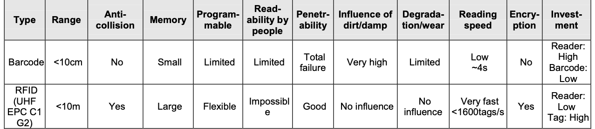
Table 2: Comparisons of RFID with Barcode in the BHS

VII. Benefits

VII.A: Cost Saving

According to Air China records, compensation for lost baggage, baggage damage, temporary cost of living, and lost internal goods of baggage amounted to $31,993, $174,986, $65,100, and $8,431 accordingly between March 19, 2005 and April 18, 2006. (as shown in Figure 12). The cost of compensation for airlines will be reduced if the chance of misreading and error rate are reduced. Over 1% of the 2 billion+ pieces of baggage handled each year in the aviation sector is mishandled, and each case of baggage mishandling costs on average $90 ^{[55]} .
RFID will save the industry US$760 million per year once fully used (based on a tag cost of US$0.10) ^{[49]} . Furthermore, due to increased productivity and a more automated workflow brought on by RFID, processing costs, including personnel and maintenance costs, are reduced. For example, at Hong Kong International Airport, the average cost of handling baggage has decreased from $7 to $4 ^{[58]} , a significant reduction, with the entire cost savings for Hong Kong airport expected to be more than US$ 3.8 million per year ^{[69].}

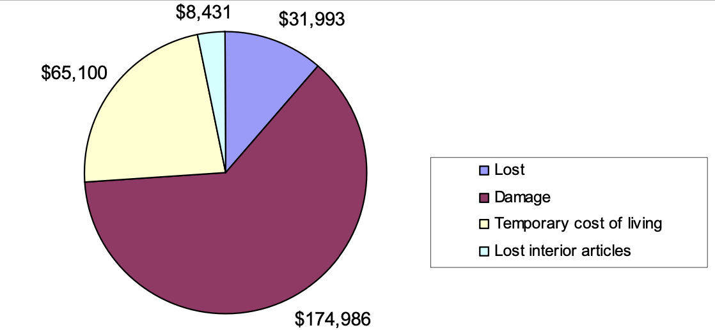 Figure 12: Compensation Cost of CA in One Year

VII.B: Efficiency Improvements

Unlike reading barcodes, the reading of tags is unaffected by dirt, partial folding, concealment, or blocking. This feature, which is appropriate for belt conveyors and container sorters, efficiently alters operation flow and drastically decreases manual processing speed and time. Because the work necessary to sort and load baggage is minimized, the manpower numbers for baggage handling are also lowered. The use of RFID accelerates the generation of the baggage loading list for the universal loading device (ULD) and streamlines the bag loading procedure due to the simultaneous scanning of numerous tags.
The ULD is an important unit to store and load the passenger baggage separated by destination. If the RFID tag on one piece of baggage whose destination is not suitable passes through the RFID field in front of the ULDs, the system distinguishes the bag from other items and audibly advises the handler whether that bag is being placed correctly or not, removing the need for manual barcode scanning and pasting when loading baggage into these containers. As a result, employing RFID to manifest exactly which baggage is in which container, facilitate the matching of baggage to passenger 'aboard aircraft' status, and find the container that carries the passenger baggage is beneficial from both a security and operational efficiency perspective. ^{[45]} .
In addition, the bags sent to the mistake sorting conveyor or late bags are read by a WiFi-enabled portable RFID scanner connected to the control center to get their information for fast delivery. The reduction of handling time and mistakes is also significant financially, because every airline in the world measures the impact of delays in terms of 'cost per delay minute ^{[45]} '.

VII.C: Potential Worthiness

U.S. Department of Transportation ^{[28]} surveys that the baggage now ranks second on the customer complaints list, and the ranking is likely to worsen in the coming years. Customer satisfaction is impacted by the issues (e.g., long baggage claim times, delayed, damaged, and missing baggage), which might result in a direct loss of business. Reduced customer satisfaction has the potential to jeopardize future income ^{[29]} .
According to ^{[10]} , when RFID technology is implemented, passenger claims will be decreased by 5.7 million. Furthermore, the RFID-based traceable system makes the consumer more aware of the performance of airport baggage and influences his airline or airport selection in his purchase decision. Remote programming of tags and the ability to write accessional data into tags are both possible with RFID.
Additionally, new value-added services, such as security check operations, real-time location systems to track ground service equipment and personnel surrounding airports (using active tags), RFID-based access control systems, and RFID for cargo, may be easily integrated into the system. The RFID data mining on the baggage database also allows for the push of special friendly or VIP services based on the passenger's attribute, behavior pattern, or interest, such as tailored reminders based on the passenger's and his baggage's location context.

VIII. Conclusion

This project was started to produce a reusable baggage tag with the use of IoT, including POS, RFID, Fusion table, and a mobile app, to solve the large number of lost baggage and the disposal of adhesive baggage tags after traveling by air.
This article looked at the newest IoT technologies, as well as the present use of RFID in the baggage handling system, and advocated the creation of a reusable baggage tag to help with the airline baggage monitoring process. For the suggested reusable tag, a framework and RFID components are described. A unique integrated IoT for a reusable baggage tag is designed instead of an extra one-off RFID tag and separate tracking device that is required for the baggage monitoring system.
A database management system and a smartphone app are proposed for tracking and tracing baggage at any time and from any location. The setup and trial run went well, showcasing the information flow from RFID data to the POS system, then to the database management system, and finally to the data being shown on a smartphone app.
The latest status of the baggage can be provided to the traveler. Some of the significant obstacles ahead include challenges to collaboration among multiple stakeholders, data flow between various parties, resistance to change among frontline employees, and a lack of vector information. The challenges ahead can be explored by improving the methodology of integrating the retail system, baggage tag, airport check-in counter, baggage handling system, aircraft, the destination airport, and hotels using tag, readers, antenna, and mobile devices, as well as upgrading the security and privacy of the IoT system. Following system modification, a comprehensive performance test could be conducted in a variety of baggage orientations, reader antennas and mobile devices, different conveyor belt systems, and both empty and loaded baggage conditions.

VIII. Conclusion

The RFID technology gives a real-time view of item-level baggage information and strengthens the automated solution in BHS, allowing for the integration of new value-added services. We describe the design, implementation, and performance of a realistic RFID system used in the BCIA airport Terminal 2 for baggage tracking. According to the findings, RFID is suitable with airport conditions and may be used to reduce operating costs, increase operational efficiency, and maintain a high level of passenger satisfaction.
Based on the experiment in the Beijing airport, we conclude that:
- I. RFID outperforms barcodes in air baggage handling scenarios due to benefits such as extended range, anti-jamming, item-level identifier, and multi-recognition. The RFID-based average read rate in our trial was 96.86 percent, whereas barcode read rates were in the range of 75 percent to 85 percent. The use of RFID will save labor costs while also creating potential value. As a result, the use of RFID to replace barcodes is unavoidable.

II. In the case of RFID-based BHS, the tags' running costs will be substantially higher than the readers' initial setup costs. We believe that the airport should bear the cost of installing the system, and that the cost of operating the system should be split proportionally by airports and airlines.
III. The maximum return on investment will not be realized until the worldwide RFID-based baggage handling network infrastructure is built. After the top big and critical airports have implemented the RFID-based BHS, medium and small airports can progressively implement the shift to RFID. As a result, for a while, the barcode-based and RFID-based systems will coexist.

References

- Carmichael, S. Airlines Losing 3000 Bags—Every Hour of Every Day. Available online: http://www.gadling. com/2010/03/26/airlines-losing-3000-bags-every-hour-of-every-day/ (accessed on 9 April 2014).
- Peterson, B.S. Why Do 26 Million Checked Bags Go Missing Every Year? The Informer. 2012. Available online: http://www.cntraveler.com/travel-tips/flying/2012/07/airlines-baggage-baggage-checked-fees- missing-bags (accessed on 10 April 2014).
- Yogerst, J. Best and Worst Airlines for Lost Baggage. Travel and Leisure. 2013. Available online: http://www.travelandleisure.com/articles/best-and-worst-airlines-for-lost-baggage (accessed on 10 April 2014).
- McCartney, S. Baggage Claim: Airlines Are Winning the War on Lost Baggage. Available online: http://online.wsj.com/articles/baggage-claim-airlines-are-winning-the-war-on-lost-baggage-1401922595 (accessed on 3 December 2016).
- Bates, J. Lost Baggage Rates Continue to Decline—New Report; Aviation Media: London, UK, 2015. Sustainability 2017, 9, 58 11 of 12
- Swedberg, C. Reusable Electronic Baggage Tag Powered by RFID. Available online: http://www.rfidjournal. com/articles/view?7928/ (accessed on 10 April 2014).
- Al-Ali, A.S.A.; Sajwani, F.; Al-Muhairi, A.; Shahenn, E. Assessing the feasibility of using RFID technology in airports. In Proceedings of the IEEE 2007 1st Annual RFID Eurasia Conference, Istanbul, Turkey, 5–6 September 2007.
- Mishra, A.; Mishra, D. Application of RFID in aviation industry: An exploratory review. Promet Traffic Transp. 2010, 22, 363–372. [CrossRef]
- DeVries, P.D. The state of RFID for effective baggage tracking in the airline industry. Int. J. Mob. Commun. 2008, 6, 151–164. [CrossRef]
- Wyld, D.C.; Jones, M.A.; Totten, J.W. Where is my suitcase? RFID and airline customer service. Mark. Intell. Plan. 2005, 23, 382–394. [CrossRef]
- Hui, J. RFID in Airports—Baggage and Passenger Tracking. Available online: http://www.winmec.ucla. edu/rfid/course/2008s/RFID%20in%20Airports.pdf (assessed on 10 December 2016).
- Medeiros, C.R.; Costa, J.R.; Fernandes, C.A. Passive UHF RFID tag for airport suitcase tracking and identification. IEEE Antennas Wirel. Propag. Lett. 2011, 10, 123–126. [CrossRef]
- Roberti, M. Airlines Could Benefit From RFID-Enabled Baggage Handling. 2013. Available online: http://www.rfidjournal.com/articles/view?10992 (accessed on 10 December 2016).
- Zoltan, K.A.T.O. Using RFID and GIS technologies for advanced baggage tracking. SEA Pract. Appl. Sci. 2015, 3, 229–234.
- Nepal, S.; Chotiyaputta, V. Operation risk management: A case study of baggage logistics technology at Munich Airport. Panyapiwat J. 2016, 8, 273–282.
- Gupta, V.; Kumar, R.; Mishra, R.G.; Semwal, A.; Siwach, S. Design and optimization of baggage tracking system on airport. In Proceeding of the International Conference on Intelligent Communication, Control and Devices, Dehradun, India, 2–3 April 2016; Springer: Singapore, 2017; pp. 833–838.
- Berrada, A.; Salih-Alj, Y. An Efficient RFID-Based Tracking System for Airport Baggage. Available online: http://elvedit.com/journals/IJACSIT/wp-content/uploads/2015/11/IJACSIT-Paper-Format.pdf (assessed on 10 December 2016).
- Ahmed, T.; Calders, T.; Pedersen, T.B. Mining risk factors in RFID baggage tracking data. In Proceedings of the 2015 16th IEEE International Conference on Mobile Data Management, Pittsburgh, PA, USA, 15–18 June 2015; Volume 1, pp. 235–242.
- Zhu, X.; Mukhopadhyay, S.K.; Kurata, H. A review of RFID technology and its managerial applications in different industries. J. Eng. Technol. Manag. 2012, 29, 152–167. [CrossRef]
- Jacinto, C.; Romano, M.; Montes, A.; Sousa, P.; Nunes, M.S. RFID tuning methodology applied on airport baggage tracking. In Proceedings of the IEEE Conferences on Emerging Technologies & Factory Automation (ETFA 2009), Palma de Mallorca, Spain, 22–25 September 2009; pp. 1–4.
- Ouyang, Y.; Hou, Y.; Pang, L.; Wang, D. An Intelligent RFID Reader and its Application in Airport Baggage Handling System. In Proceedings of the 4th International Conference on Wireless Communications, Networking and Mobile Computing (WiCOM’08), Dalian, China, 12–14 October 2008; pp. 1–4.
- Cerino, A.; Walsh, W.P. Research and application of radio frequency identification (RFID) technology to enhance aviation security. In Proceedings of the IEEE 2000 National Aerospace and Electronics Conference (NAECON 2000), Dayton, OH, USA, 10–12 October 2000; pp. 127–135.
- Sennou, A.S.; Berrada, A.; Salih-Alj, Y.; Assem, N. An interactive RFID-based bracelet for airport baggage tracking system. In Proceedings of the 2013 4th International Conference on Intelligent Systems, Modelling and Simulation, Sabah, Malaysia, 8–10 February 2013.
- Chen, X.Y.; Jin, Z.G. Research on key technology and applications for internet of things. Phys. Procedia 2012, 33, 561–566. [CrossRef]
- Sun, C. Application of RFID technology for logistics on internet of things. AASRI Procedia 2012, 1, 106–111. [CrossRef]
- International Telecommunication Union (ITU); Strategy and Policy Unit (SPU). ITU Internet Reports 2005: The Internet of Things; International Telecommunication Union (ITU): Geneva, Switzerland, 2005.
- Gubbi, J.; Buyya, R.; Marusic, S.; Palaniswami, M. Internet of Things (IoT): A vision, architectural elements, and future directions. Future Gener. Comput. Syst. 2013, 29, 1645–1660. [CrossRef]
- Xia, F.; Yang, L.T.; Wang, L.; Vinel, A. Internet of things. Int. J. Commun. Syst. 2012, 25, 1101–1102. [CrossRef] Sustainability 2017, 9, 58 12 of 12
- Atzori, L.; Iera, A.; Morabito, G. The internet of things: A survey. Comput. Netw. 2010, 54, 2787–2805. [CrossRef]
- Kortuem, G.; Kawsar, F.; Fitton, D.; Sundramoorthy, V. Smart objects as building blocks for the internet of things. IEEE Intern. Comput. 2010, 14, 44–51. [CrossRef]
- Geum, Y.; Lee, S.; Kang, D.; Park, Y. Technology roadmapping for technology-based product-service integration: A case study. J. Eng. Technol. Manag. 2011, 28, 128–146. [CrossRef]
- Ehrman, K.S.; Ehrman, M.L.; Jagid, J.M. Mobile Portal for RFID Baggage Handling Applications. U.S. Patent 7,656,273, 2 February 2010.
- Baskas, H. Digital Bag Tags Could Make Paper Baggage Tags Obsolete. Available online: http://www.cnbc. com/id/101188221 (accessed on 10 April 2014).
- Collotta, M.; Pau, G.; Tirrito, S. A preliminary study to increase baggage tracking by using a RFID solution. In Proceedings of the International Conference on Numerical Analysis and Applied Mathematics 2014 (ICNAAM-2014), Rhodes, Greece, 22–28 September 2014; AIP Publishing: Melville, NY, USA, 2015; Volume 1648, p. 780005.
- Mishra, D.; Mishra, A. Improving baggage tracking, security and customer services with RFID in the airline industry. Acta Polytech. Hung. 2010, 7, 2.
- Song, J.G.; Kim, D.H.; Na, D.G. Apparatus and Method to Control Taking Airport Baggage. U.S. Patent 9315278 B2, 19 April 2016.
- Bravman, R.; Wang, Y.P.; Toedt, D.C., III; Vingsbo, S.G. Traveler Security and Baggage Control System. U.S. Patent 5,866,888, 2 February 1999.
- Chang, Y.S.; Oh, C.H.; Whang, Y.S.; Lee, J.J.; Kwon, J.A.; Kang, M.S.; Park, J.S.; Ung, Y.P. Development of RFID Enabled Aircraft Maintenance System. In Proceedings of the 2006 IEEE International Conference on Industrial Informatics, Singapore, 16–18 August 2006; pp. 224–229.
- Brennan, P. RF-ID tag and video passenger location in airports. J. Airpt. Manag. 2007, 2, 56–66.
- Zhang, T.; Ouyang, Y.; He, Y. Traceable air baggage handling system based on RFID tags in the airport.
J. Theor. Appl. Electron. Commer. Res. 2008, 3, 106–115.
- Ghazal, M.; Ali, S.; Haneefa, F.; Sweleh, A. Towards smart wearable real-time airport baggage tracking. In Proceedings of the 2016 International Conference on Industrial Informatics and Computer Systems (CIICS), Sharjah, UAE, 13–15 March 2016; pp. 1–6.
- Wolber, D.; Abelson, H.; Spertus, E.; Looney, L. App Inventor Create Your Own Android Apps; O’Reilly Media, Inc.: Oakville, ON, Canada, 2011.
- Airport Business. Making RFID Work—The Most Effective Solution to Lost Baggage? Airport Business, Baggage Handling. Available online: http://www.airport-business.com/2009/03/making-rfid-work-the- most-effective-solution-to-lost-baggage/ (accessed on 12 April 2014).
- Beijing Capital International Airport Co. Ltd.. Company Introduction. [Online]. Available: http://www.bcia.com.c n/en/about_company_page.html.
- A. Cerino, and W. P. Walsh, Research and Application of Radio Frequency Identification (RFID) Technology to Enhance Aviation Security, presented at the IEEE 2000 National Aerospace and Electronics Conference, Dayton, OH, October 10-12, 2000, pp. 127-135.
- P. Chartier. (2005). An Overview of ISO RFID Standards Applied to IATA Baggage Handling, Technical Report. [Online]. Available: http://www.iata.org/NR/rdonlyres/53329227-F16B-4FB8-A311-BADB1F431C12/0/ISORFID DataProtocol.pdf.
- R. Das. (2007, May). The Myth and Reality of Baggage Tagging. [Online]. Available: http://www.idtechex.com/p roducts/en/articles/00000534.asp.
- EPCglobal. (2006). EPCTM Radio-Frequency Identity Protocols Class-1 Generation-2 UHF RFID Protocol for Communications at 860 MHz–960 MHz Version 1.0.9. [Online]. Available: http://www.epcglobalinc.org/standar ds/uhfc1g2/uhfc1g2_1_0_9-standard-20050126.pdf.
- EPCglobal. (2006, March). EPCglobal Tag Data Standards Version 1.3. [Online]. Available: http://www.epcgloba linc.org/standards/tds/tds_1_3-standard-20060308.pdf.
- EPCglobal. (2006). Object Naming Service (ONS) Version 1.0 EPCglobal Ratified Specification. [Online]. Available: http://www.epcglobalinc.org/standards/ons/ons_1_0-standard-20051004.pdf.
- K. Finkenzeller. RFID Handbook: Fundamentals and Applications in Contactless Smart Cards and Identification (Second Edition). New York: John Wiley & Sons, 2003.
- P. Harrop. (2006, August). RFID in the Air Industry and Land Transport. [Online]. Available: http://www.idteche
  - x.com/products/en/articles/00000486.asp.
- International Air Transport Association. (2007). RFID Business Case for Baggage Tagging. [Online]. Available:
  - http://www.iata.org/NR/rdonlyres/99091491-CB49-4913-BAB4-EA578CA814CC/0/RFIDforbaggagebusinesscas
  - e21.pdf.
- International Air Transport Association. (2007). IATA RFID Tutorials - RFID Encoding To RP1740c. [Online].
  - Available: http://www.iata.org/NR/rdonlyres/FEE3B583-A9E0-4AF0-B81A-9E97A7AAD574/0/RFIDEncoding tuto
  - rial.pdf.
- International Air Transport Association. (2007, August). Fact Sheet: Radio Frequency Identification (RFID) for Aviation. [Online]: Available: http://www.iata.org/pressroom/facts_figures/fact_sheets/RFID.htm.
- International Air Transport Association. (2006, January). Simplifying the Business Strategy 2006: RFID. [Online]: Available: http://www.iata.org/NR/rdonlyres/9CABFA21-BE46-426C-AA6E-9E568C1F656F/0/2006StrategyRFI
  - D.ppt.
- International Air Transport Association. (2007). RFID Transition Plan for Baggage. [Online]. Available: http://www.iata.org/NR/rdonlyres/081E47E4-6EF7-474F-AD64-C9C6671FDAF1/0/RFIDTransitionPlanfor baggage12.pdf.
- Intermec Technologies. (2006). Product Profile - IF5 Fixed Reader. [Online]. Available: http://epsfiles.intermec.com/eps_files/eps_spec/IF5_spec_web.pdf.
- Y. M. Lee, F. Cheng, and Y. T. Leung, Exploring the Impact of RFID on Supply Chain Dynamics, Proceedings of the 2004 Winter Simulation Conference, Dec. 5-8, 2004, pp. 1145-1152.
- m2p Consulting, Implementing RFID Tagged Baggage, The 3rd Annual Middle East Aviation IT Manager Forum, Technical Report, November, 2005.
- A. Moses. (2006, November). Lost in Transit no More: RFID Baggage Tracking. [Online]. Available: http://www.indoorlbs.com/id151.html.
- P. Nemeth, L. Toth, and T. Hartvanyi, Adopting RFID in Supply Chains, presented at 2006 IEEE International Conference on Mechatronics, July 2006, pp. 263-266.
- M. C. O'Connor. (2005, November). IATA Approves UHF for Bag Tags. [Online]. Available: http://www.rfidjournal.com/article/articleview/1994/.
- M. C. O'Connor. (2005, September). Alien Drops Tag Price to 12.9 Cents. [Online]: Available: http://www.rfidjournal.com/article/articleview/1870/1/1.
- E. C. Ozelkan, Y. Sireli, M. P. Munoz, and S. Mahadevan, A Decision Model to Analyze Costs and Benefits of RFID for Superior Supply Chain Performance, presented at Technology Management for the Global Future, 2006. PICMET 2006, Istanbul, Turkey, July 2006, pp. 610-617.
- L. Riley. (2005, November). IATA Introduces RFID Standard for Baggage Tags Annual Industry Savings Projected at US$760 Million. [Online]. Available: http://www.iata.org/pressroom/briefings/2005-11-18-01.
- M. Roberti. (2006, May). SmartCode Offers 5-Cent EPC Tags. [Online]: Available: http://www.rfidjournal.com/article/articleview/2296/1/1.
- F. Sahin, J. Robinson, and E. Powell, Information Sharing and Coordination in Make-to-Order Supply Chains, Journal of Operations Management, vol. 23, no. 6, pp. 579-598, 2005.
- SITA.(2007,June).TheArrival of RFID.[Online]:Available: http://www.sita.aero/News_Centre/Publications/Solutions_at_SITA_Q2_2007/Features/The_arrival_of_RFID.htm.
- UPMRaflatac.UHFProducts.[Online].Available: http://www.upmraflatac.com/asia/eng/RFIDProducts/UHFProducts.
- U.S. Department of Transportation. (2006, October). Air Travel Consumer Report. [Online]. Available: http://airconsumer.ost.dot.gov/reports/atcr06.htm.
- C. Vincent, H. Deijkers, J. Strik, V. Atmadja, D. Polizzi and M. S. Boyce, Beyond the Carousel-Better Baggage Handling Through Enhanced Collaboration Among Airlines and Airports, IBM Institute for Business Value, NY,
- USA, Technical Report, 2007. D. Vollmer, RFID: From Compliance to Competitive Advantage, Sr. Logistics Consultant RedPrairie Corporation,
- USA, Technical Report, 2004. R. Weinstein, RFID: A Technical Overview and Its Application to the Enterprise, IT Professional, vol. 7, no. 3, pp.27-33, 2005.
- N.C. Wu, M.A. Nystrom, T.R. Lin and H.C. Yu, Challenges to Global RFID Adoption, presented at Technology Management for the Global Future, 2006. PICMET 2006, Istanbul, Turkey, July 2006, pp. 618-623.

